Payroll System Specification

Team Members: Thanh Pham & Muhammad Qamar

Date: 04/23/2023

**1 Assignment and Environment**

**Project: Payroll System**

**Assigned to: Thanh Pham & Muhammad Qamar**

**Work Assignment Number: N/A**

**Platform: Windows 11 Home**

**Language/Tool: SQL, Visio, SSMS (Microsoft SQL Server Management Studio), Azure Data Studio, Microsoft Access**

**Task ID: 1**

**Author of Specifications: Thanh Pham & Muhammad Qamar**

**2 Program Overview**

The purpose of this system is to help the company to handle Payroll data faster and accuracy. Besides, low down the paperwork for the HR department and most of the data will be stored on the company's system and cloud. Also, friendly environment application for an employee to track their information on Payroll, attached savings and tax calculate functions.

# 3 Inputs & Graphical User Interface (GUI)

Figure 1: This is what the users will see when logging in on the iPad.

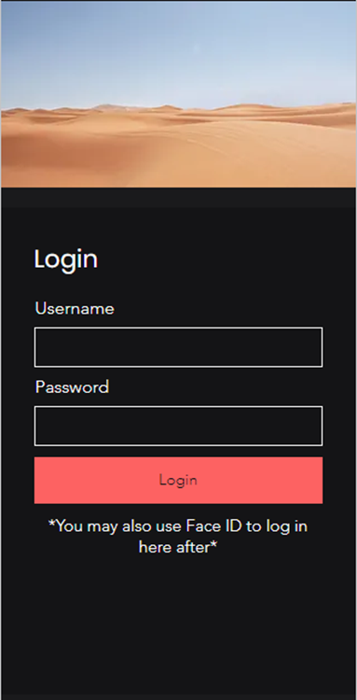

Figure 2: The user can then select a service they would like to view.

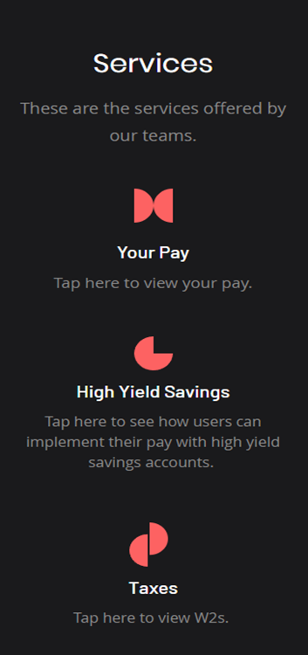

# 4 Outputs

Figure 4: This is the database from which the information is pulled.

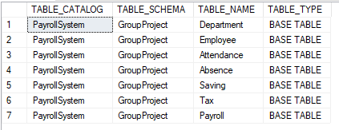

# 5 Database Tables

These are some of the most used tables in our payroll system.

Figure 5: Employee table is shown

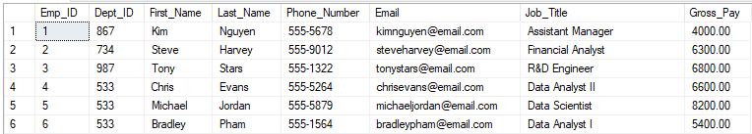

Figure 6: Department table is shown

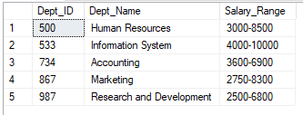

Figure 7: Savings table is shown

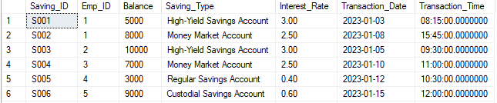

# 6 Detailed Code

Below are snippets of the code used to create our database. From creating our database, we were able to publish the system, we will show snippets of the code needed to create some of the most important tables within the database. (SSMS - SQL Server Managment Studio)

**6.1 Code for Employees Table**

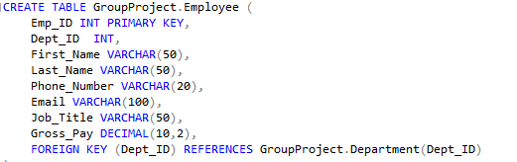

**6.2 Code for Savings Table**

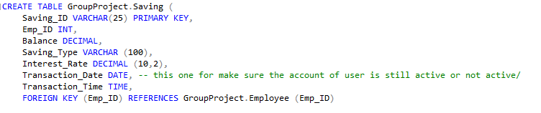

**6.3 Code for Payroll Table**

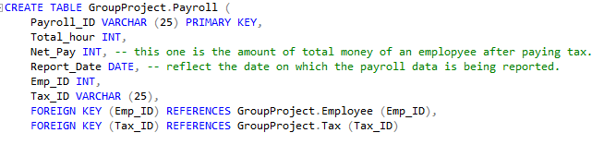

**7 Data Source – This section outlines the database & entity relationship to support Section #3**

## 7.1 Input File

Retrieval of information from the SQL DATABASE (SSMS)

After you clock in on application, the system will automate send the information to company server in the SQL database and store on it. HR department can convert information to Excel or Table on SSMS to viewing.

**ERD DIGRAM FOR SHOWING RELATIONSHIP BETWEEN ENTITY RELATIONSHIP**

## 7.2 Output File

* Appends to SQL database via ‘Update’
* Receipts are stored to a default directory and printed
* Query to find necessary information via SQL database
* Generating report via SQL Server Report

**7.3. Report**

This Report show the total hour working of 20 employees in a month (Include SQL query). The picture is showing Azure Data Studio Platform. You can use both platform SSMS and Azure Data Studio (they are linked together by company server)

SQL Query:

SELECT Employee.Emp_ID, Employee.First_Name,Employee.Last_Name,

SUM(DATEDIFF(MINUTE,Attendance.Clockin_Time, Attendance.Clockout_Time) - DATEDIFF(MINUTE, Attendance.Breaktime_Start, Attendance.Breaktime_End)) / 60.0 AS Total_Hours_Worked

FROM GroupProject. Employee

JOIN GroupProject.Attendance Attendance ON Employee.Emp_ID = Attendance.Emp_ID

GROUP BY Employee.Emp_ID,Employee.First_Name, Employee.Last_Name;

**8 Error Handling**

This section is an important aspect of the payroll systems that helps to ensure the accuracy and reliability of the data being processed. This involves implementing measures to detect and handle any abnormal I/O errors that may occur during the process, such as issues with opening, reading, or writing files. Some the solution for potential errors:

* Built-in error to handle procedures that will trigger in the event of an error.
* Taking action to avoid further errors from occuring such as "logging the error"

**9 Testing**

Testing will be manually performed by persons knowledgeable about the existing system. Transactions will be entered into the Payroll System and stored in the database. The database records will be compared with the expected results to verify the accuracy of the system. The following types of testing will be performed

9.1 Unit testing

* Each part of the system will be tested to ensure they function correctly to meet the design needed (design phase)

9.2 System testing

* Whole system will be tested to make sure all components work together smoothly and meet the functional requirements

9.3 Integration testing

* Test with external systems, such as finance software to ensure they integrate correctly and the data transmission is accurate.

9.4 Data Transmission Tests

* The system will be tested to see that data transmssion between the users and the server is following regulations and policies, accurate, and efficient.

9.5 Parallel testing

* Running old and new system to compare working performance between them.